Implementing Script

Create Mule Project in anyPointStudio

Open the XML file

And add the Listener.

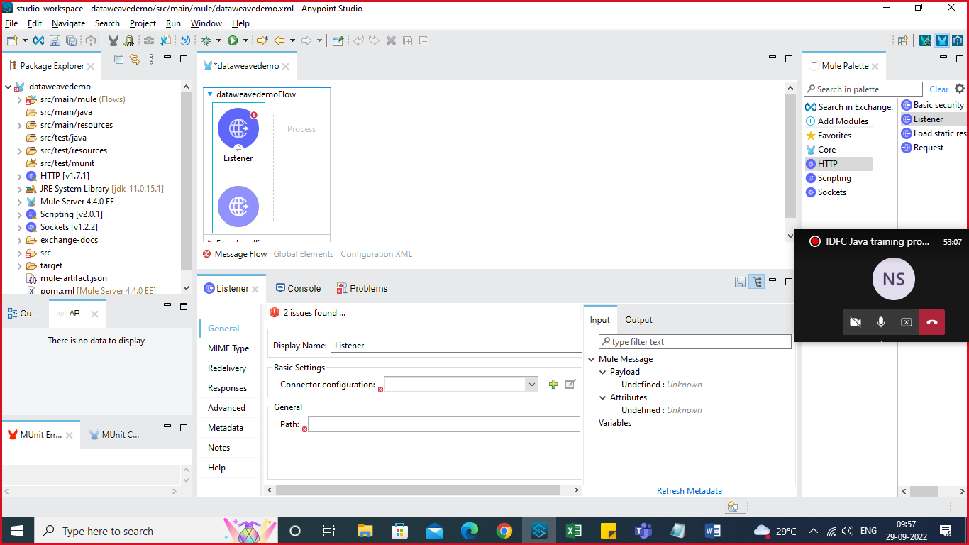

Click on the + icon and add the Listener Configuration.

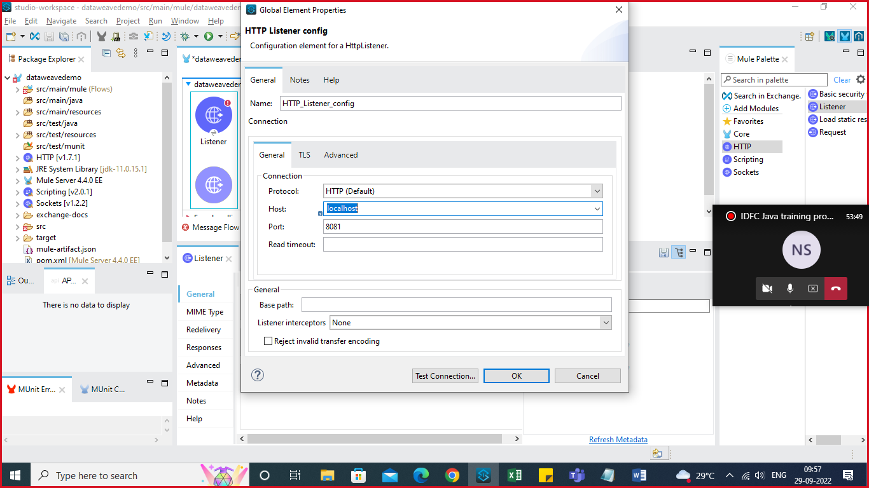

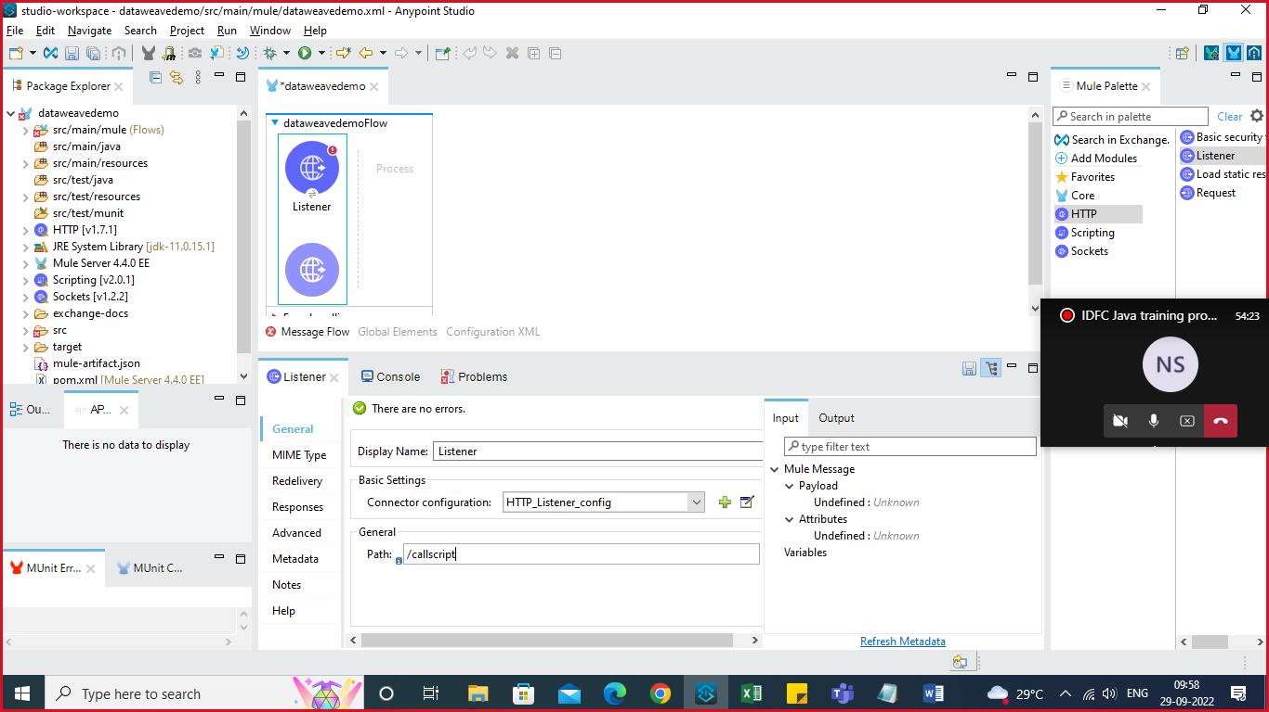

Add path /callscript

Create a Transform Message.

Add EmployeeDetails in Transform Message

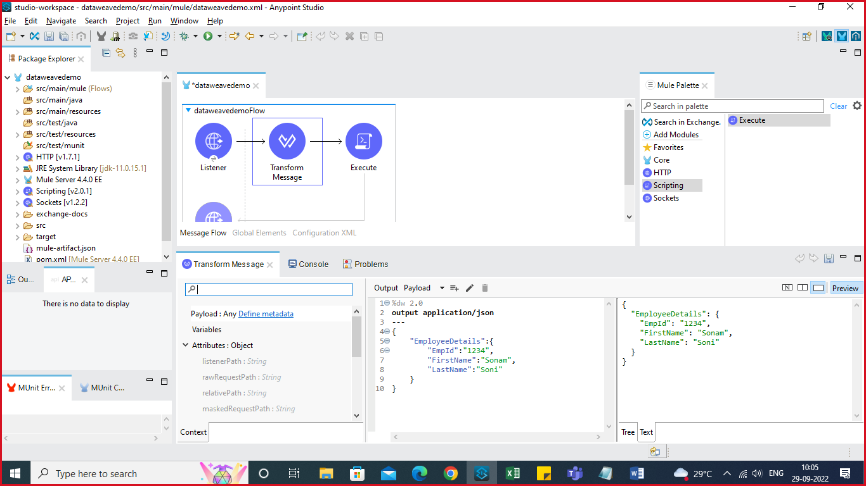

Create Script by adding Execute component near to Transform Message.

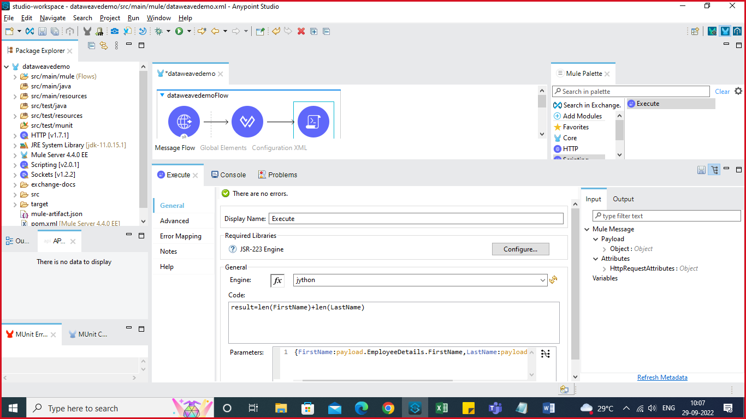

Select Engine ad jpython to run the Python Script

In code add var result which is calculating the total for fname and lname’s length.

From where this firstname and Lastname value to take

So pass parameter and get the value from the payload.

Add another Transform message to transform the result.

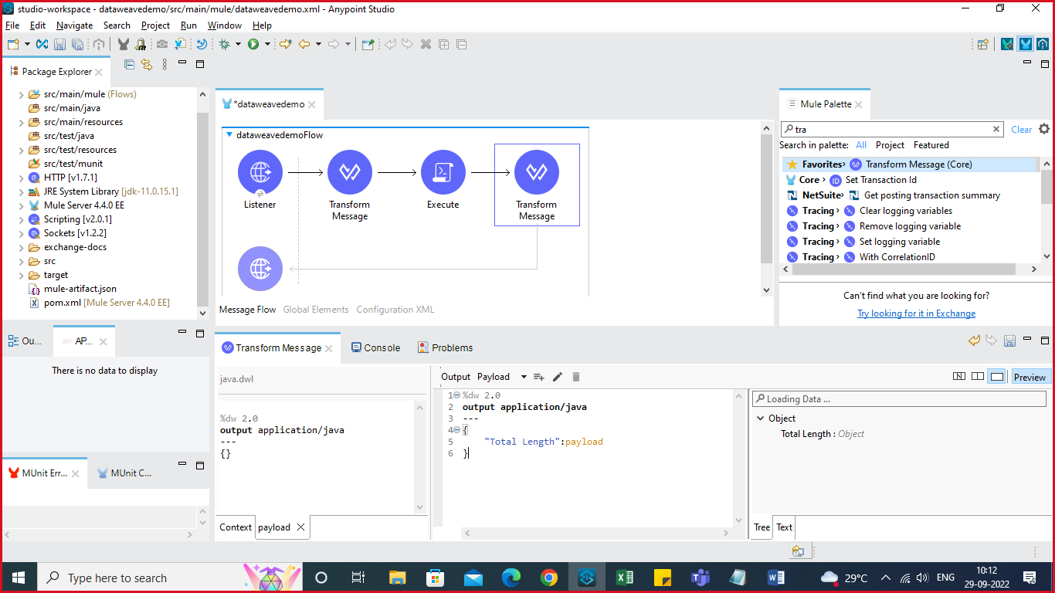

Edit the output file as above. Change output: application/json

Add the Logger to Log the details.

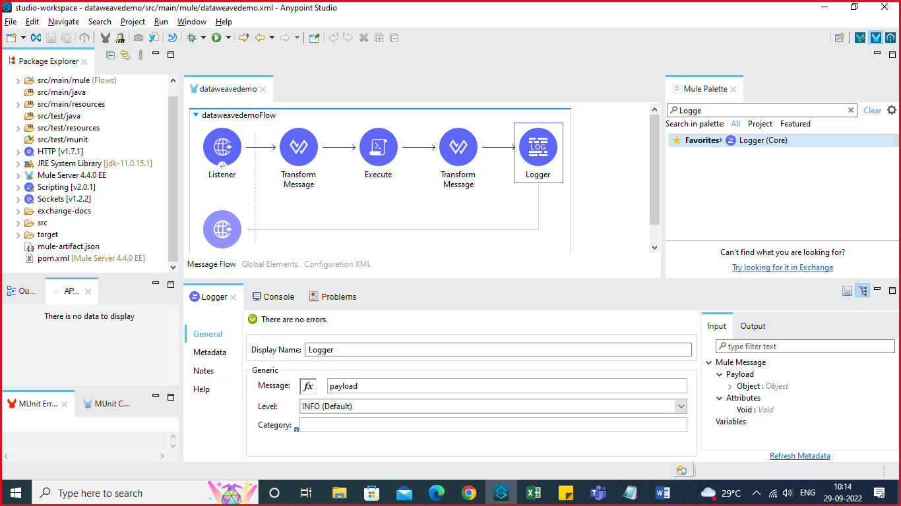

Save the File, run the same and check the Output.